Empathy Map Canvas
Ideation Phase | Working user persona
Project | Automated Network Request Management | Date | 20 October 2026
Owner / demonstrator | PILLEM RAHUL | SkillWallet ID | SWUID2026232277
Platform | ServiceNow PDI | Repository | https://github.com/rahulp06/Automated_Network_Request_Management_in_ServiceNow

Phase: 1. Ideation Phase
Method note This empathy map is a structured working hypothesis based on the solution scope and observed catalog fields. Validate with real users if primary research is required by the rubric.

Persona: Network Requester
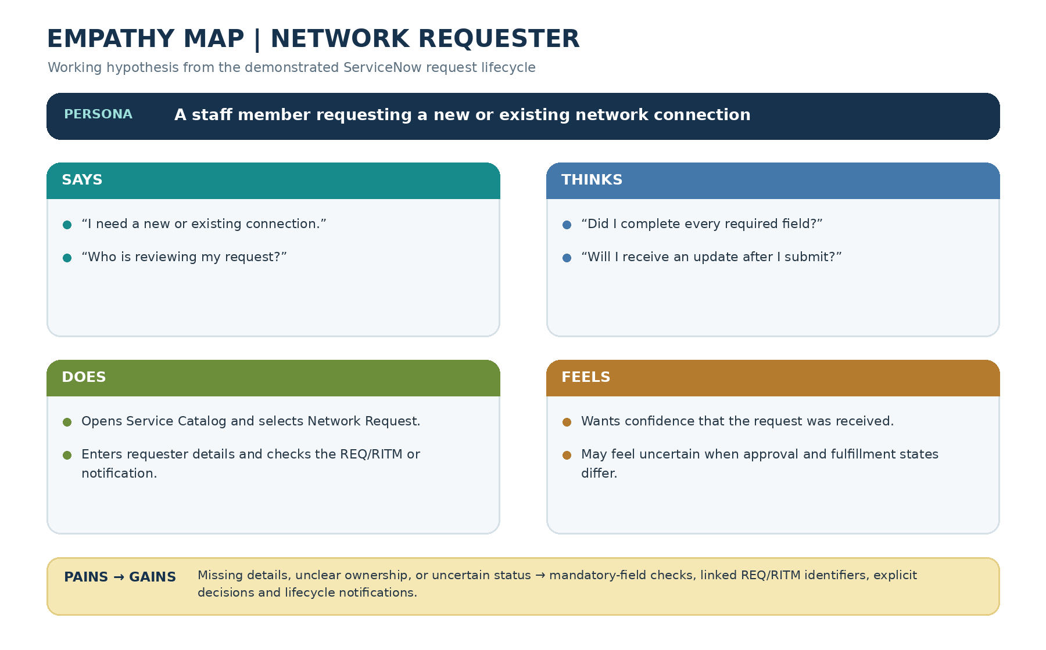
Figure 1. Visual empathy map for the working requester persona. Persona statements are hypotheses from the workflow, not primary research findings.
Says | Thinks | Does | Feels
“I need to request a new or existing connection.” | “Did I provide all the required details?” | Opens Service Catalog, chooses Network Request, fills variables. | Wants confidence that the request was received.
“Who is reviewing this?” | “Will I get an update?” | Submits request and checks REQ/RITM state or notification. | May feel uncertain if state and fulfillment stage differ.

Pains and gains
Pains | Desired gains
Missing fields or incomplete request details. | Mandatory variables are checked before ordering.
No clear record to reference after submission. | REQ number and linked RITM provide a traceable record.
Uncertainty about whether a decision was recorded. | Approval/rejection path is clear and produces lifecycle messages.
Email delivery issues in a development instance. | Safe test routing and diagnostics allow QA without notifying real recipients.

Design implications
- Use a single catalog item as the intake point.
- Mark essential variables as mandatory and test the incomplete-order path.
- Retain standard ServiceNow request identifiers and related-item linkage.
- Keep QA email routing explicit and do not expose credentials in screenshots or documentation.

